**ASSISTED LABS**

* 1. **set up and creating a new repository**

**1** installation git from chrome browser

2 executing some basic commands

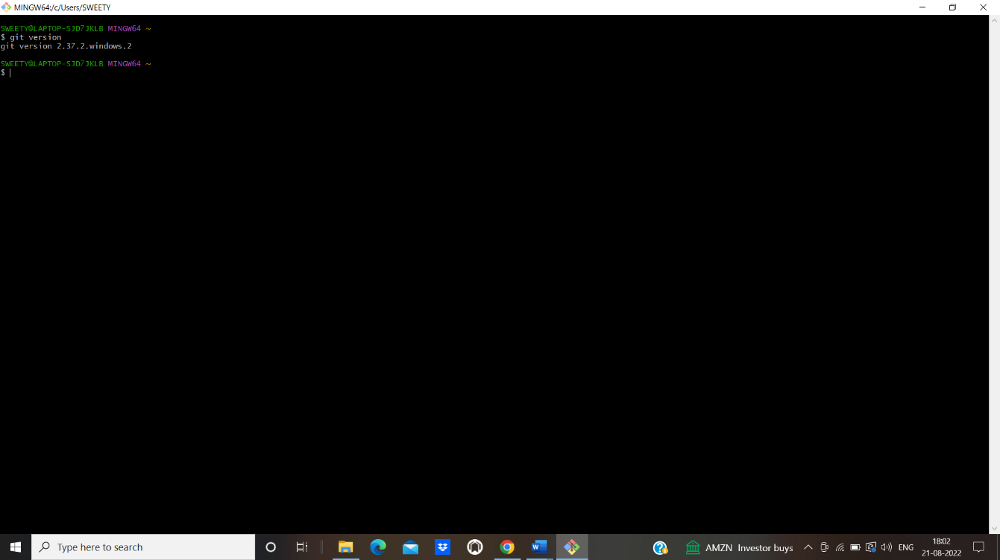

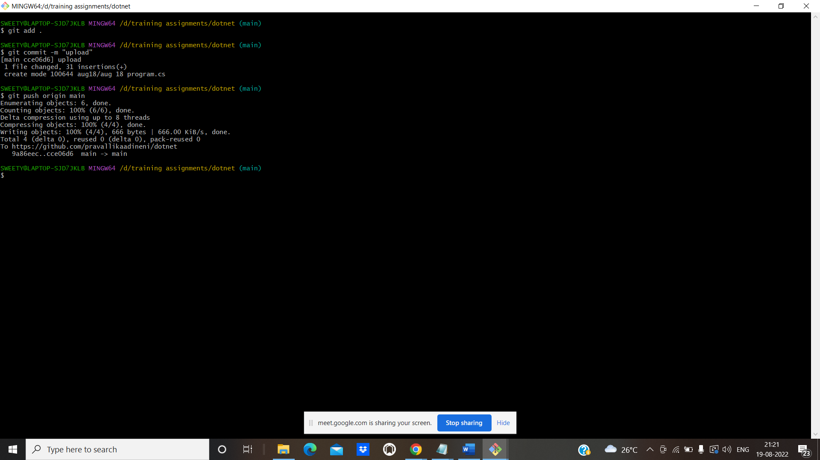

COMMANDS:

git version

git clone <https://github.com/pravallikaadineni/dotnet>

git add .

git commit -m “upload”

git push origin main

* 1. **crud operations on git**

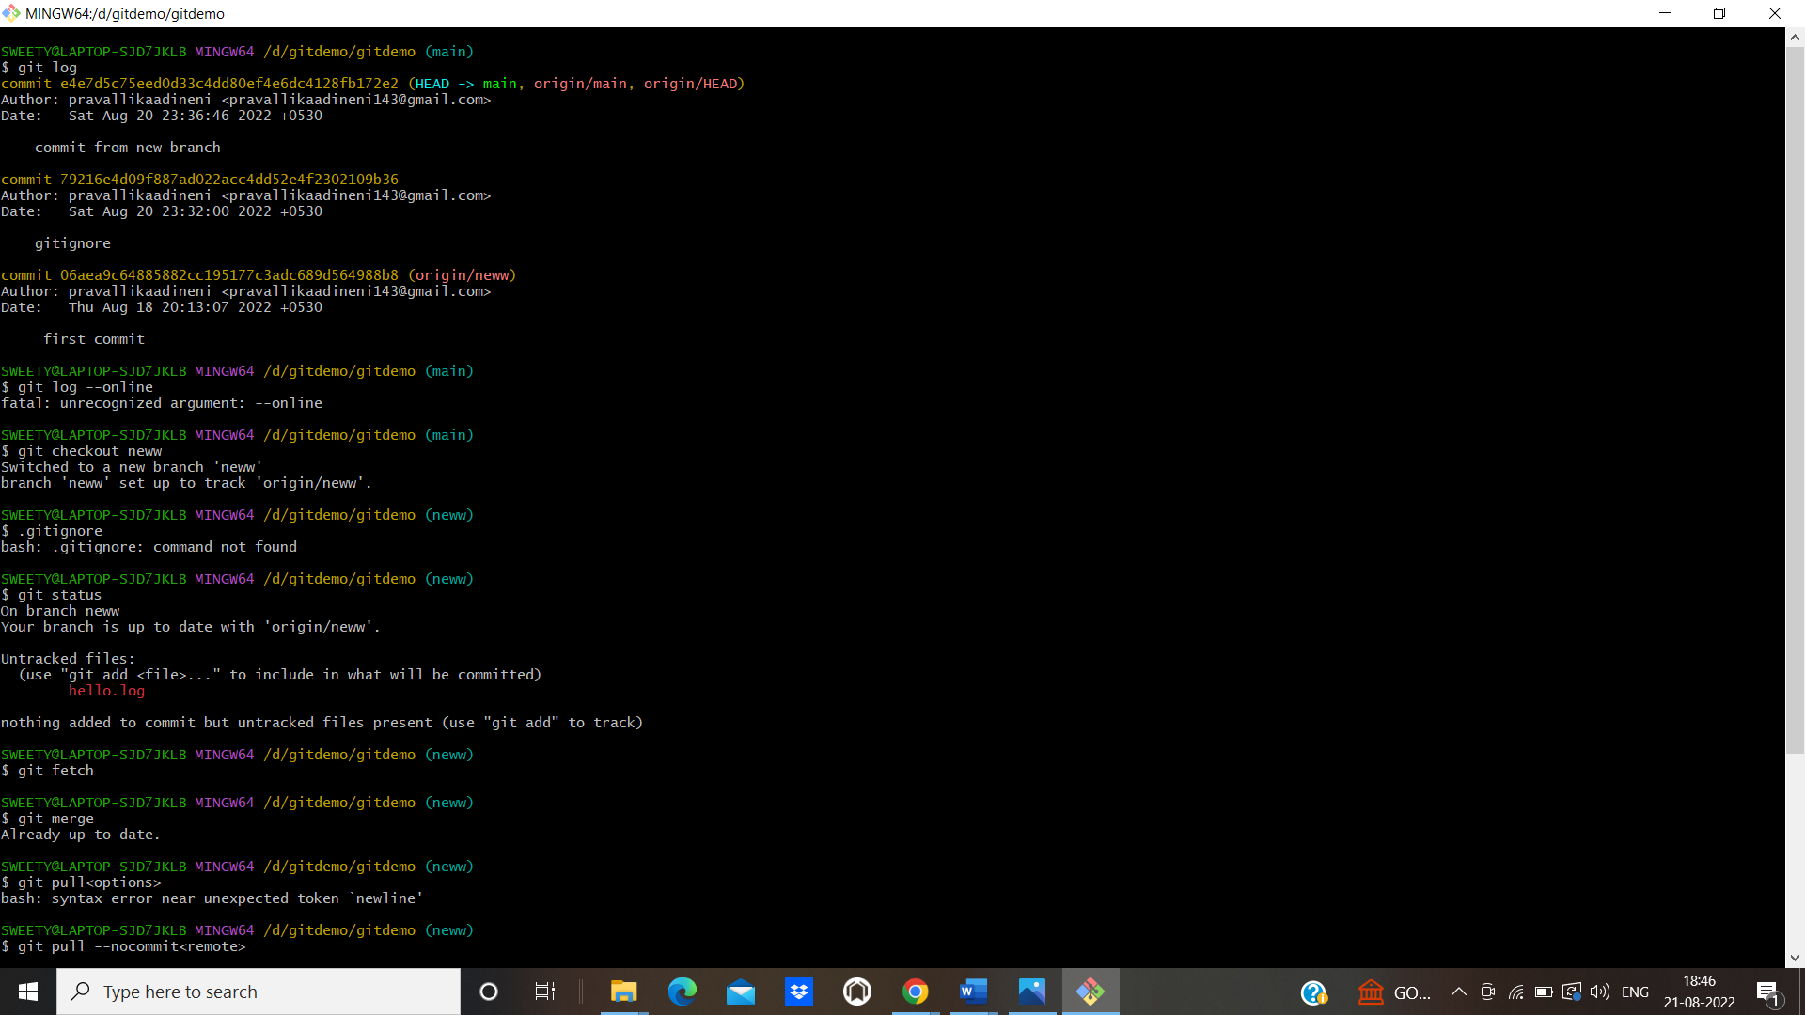

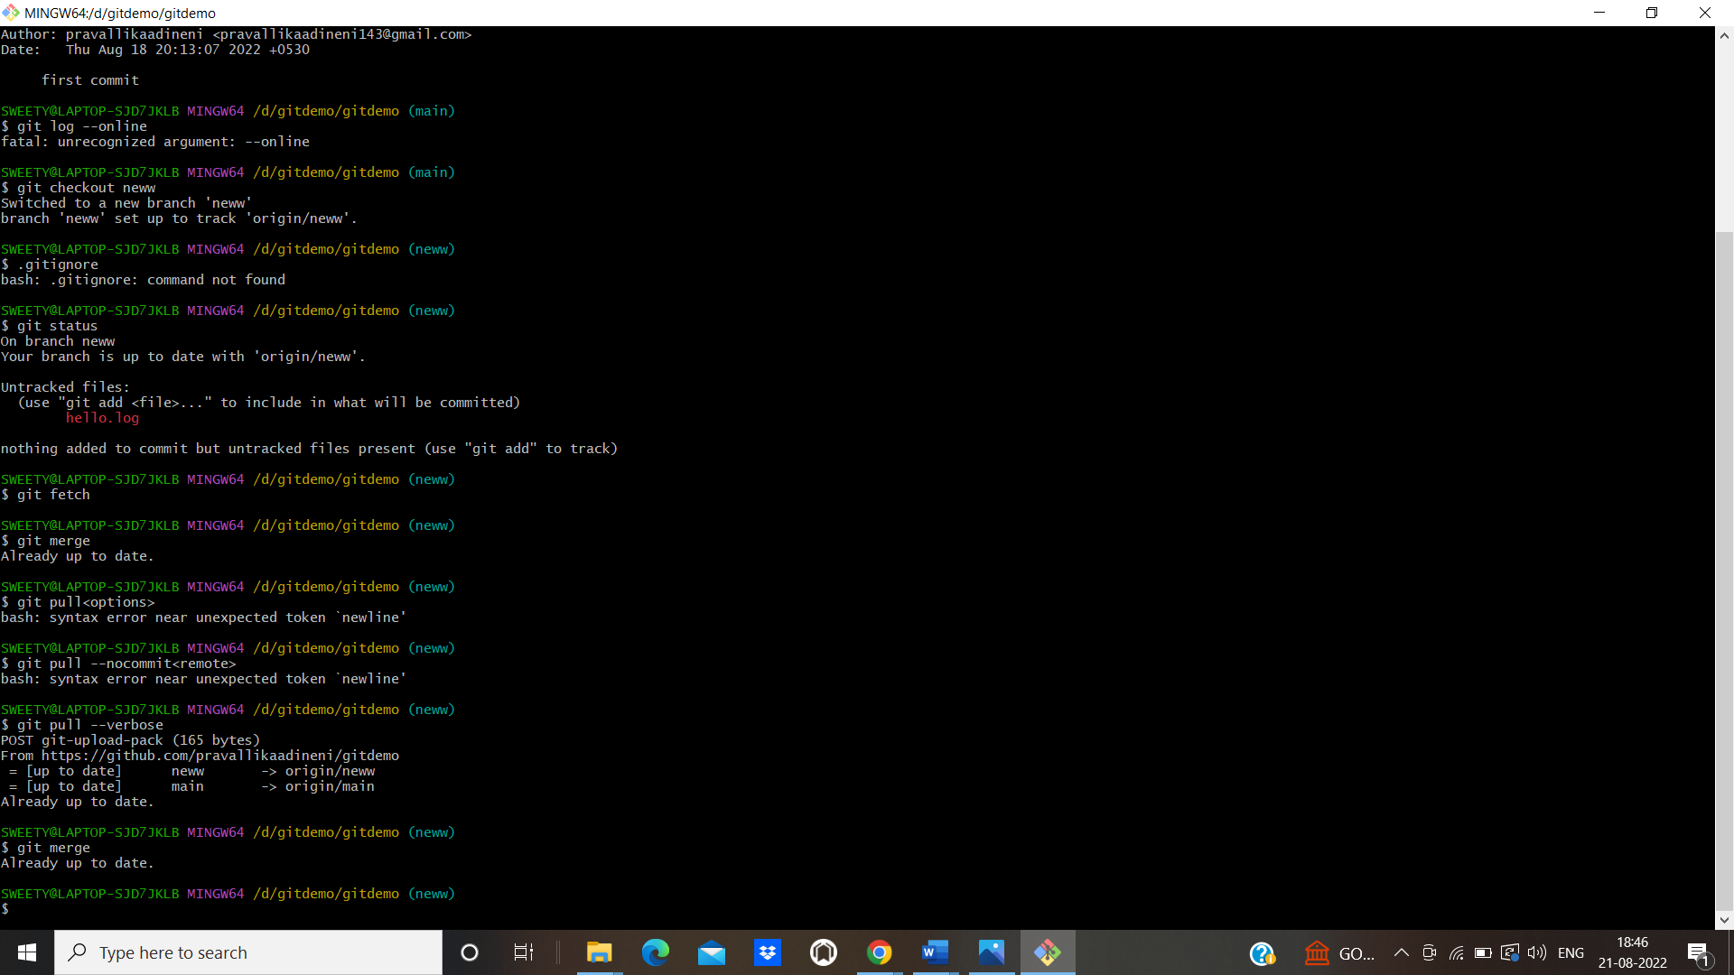

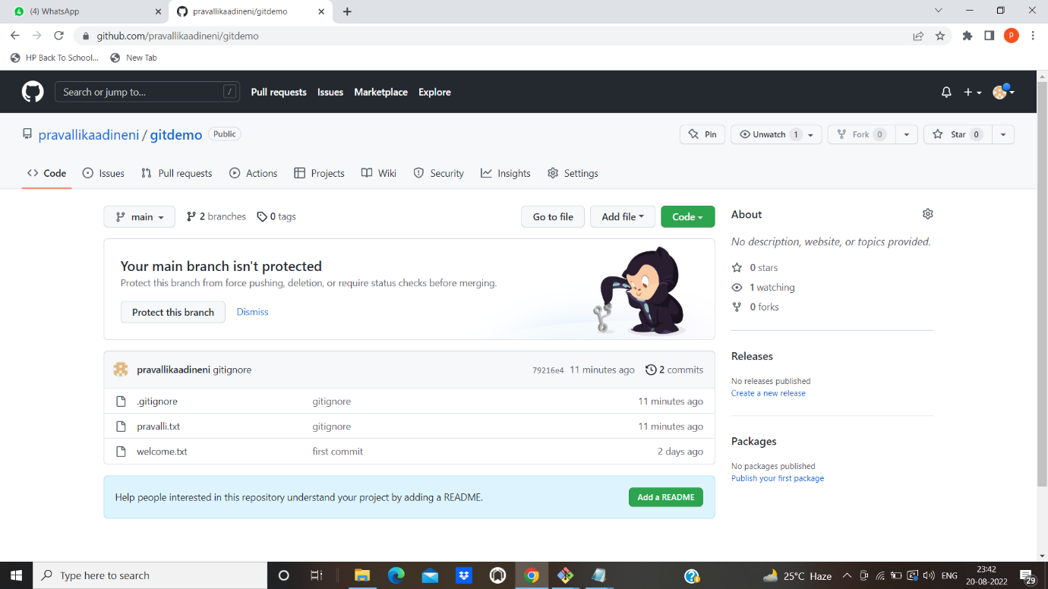

Commands:

git log

git log –online

git checkout<new>

. gitignore

git fetch

git merge

git pull –verbose

**1.3 Setup and configuring GitHub account**

**1** Creating git account using credentials and signing in in account using mail and password.

